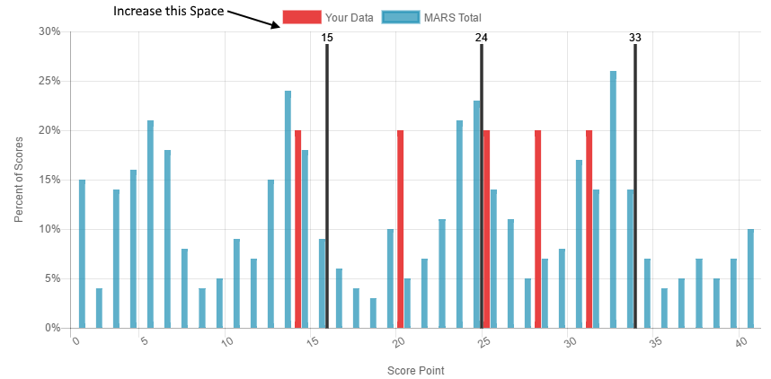

Retail Sales and Marketing, Profit and Cost

Executive Summary

Introduction
In this report, I analyze the sales and marketing data of Company to provide insights that will help stakeholders make decisions during the company's expansion process. Using Power BI, I have created a multi-tab dashboard that focuses on sales, marketing, profit, and cost across different years and ordering methods. The visualizations created in Power BI allow stakeholders to easily interpret complex data and identify trends, successes, and areas for improvement.
Business Question
To assist ABC Company during its expansion, I aim to answer the following business question: What are the trends and performance in terms of cost, revenue, and price across different years and ordering methods?
To address this question, I require data on sales, marketing, profit, and cost. The provided dataset includes this information, enabling us to perform a comprehensive analysis.

Making Sense of Data
The dataset i choose contains various fields related to sales and marketing, profit, and cost. Key columns include:
- Sales: Total sales revenue generated.
- Marketing: Marketing expenses incurred.
- Profit: Profit earned after subtracting costs from revenue.
- Cost: Costs associated with production and sales.
- Year: Year of the sales data.
- Ordering Method: Method used for placing orders (e.g., online, in-store).
These columns are crucial as they allow us to analyze the performance of the company over different periods and ordering methods. By examining this data, I can identify trends, measure the effectiveness of different strategies, and make data-driven decisions.
Business Intelligence
Using Power BI, I will create visualizations that address the company's business problem. Power BI is a powerful tool for creating interactive and intuitive dashboards that can convey complex information in a simple and understandable manner.
The tool will enable stakeholders to:
- Show trends and pattern in sales and market data.
- Identify the most profitable years and ordering methods.
- Understand the marketing expenses and revenue.
- Make data-driven decisions to improve performance and profitability.

Software Integration
The provided dataset was uploaded into Power BI, ensuring that all columns were formatted correctly. Monetary values were formatted as currency, and dates were formatted appropriately. This step ensures that the data is ready for analysis and visualization.

Guiding Questions and Answers
Based on the initial analysis, we developed the following business questions:
- Which year had the highest sales?
  - Visualization: A line chart displaying sales across different years.
  - Answer: This will show the trend of sales over the years and highlight the peak sales year.
- Which ordering method is most profitable?
  - Visualization: A bar chart comparing profits across different ordering methods.
  - Answer: This will reveal the ordering method that generates the most profit.
- How do costs impact overall profit?
  - Visualization: A scatter plot showing the relationship between costs and profit.
  - Answer: This will help understand the impact of costs on the company's profitability.
These visualizations effectively answer the business questions and provide actionable insights. The compiled and cleaned data allows us to create meaningful and accurate visualizations that help stakeholders make informed decisions.

Visualizations
Choosing Appropriate Visualizations
- Line Chart for Yearly Sales Trends:
  - Reason: Line charts are excellent for showing trends over time. This chart allows us to observe changes in sales over different years, identifying peaks and troughs.
  - Targeted Audience Interaction: Stakeholders can easily interpret the rise and fall of sales over the years, helping them identify successful periods and plan future strategies.
- Bar Chart for Ordering Method Profitability:
  - Reason: Bar charts are ideal for comparing different categories. This chart compares the profitability of various ordering methods, making it easy to see which method is the most profitable.
  - Targeted Audience Interaction: This visualization helps stakeholders quickly identify the most and least profitable ordering methods, informing decisions on where to focus resources.
- Line Chart for Marketing Expenses Over Years:
  - Reason: Similar to the sales trend, a line chart is used to show how allowing for easy trend analysis marketing expenses have changed over the years.
  - Targeted Audience Interaction: By using this stakeholder can see increased marketing spending correlate with increased sales, helping to justify or reevaluate marketing budgets.
- Scatter Plot for Cost vs. Profit Analysis:
  - Reason: Scatter plots are useful for showing the relationship between two variables. This plot illustrates how costs impact profit, highlighting any correlations.
  - Targeted Audience Interaction: This visualization helps stakeholders understand the balance between spending and profit, guiding cost management strategies.
Generating Visualizations
- Line Chart for Yearly Sales Trends:
  - Visualization: This chart shows the total sales revenue for each year, highlighting periods of growth or decline.
  - Data Used: Year, Sales.
- Bar Chart for Ordering Method Profitability:
  - Visualization: This chart compares the total profit generated by each ordering method.
  - Data Used: Ordering Method, Profit.
- Line Chart for Marketing Expenses Over Years:
  - Visualization: This chart shows the total marketing expenses for each year.
  - Data Used: Year, Marketing Expenses.
- Scatter Plot for Cost vs. Profit Analysis:
  - Visualization: This plot shows the relationship between costs and profit, with each point representing a different year or ordering method.
  - Data Used: Cost, Profit.
Visual Data Correlations
- Integrating Additional Data: We can include additional data such as region or product category to create more detailed correlations. For instance, we could use different colors in the scatter plot to represent different regions, helping to identify regional cost-profit relationships.
Inserting Data Visualizations and Explanation
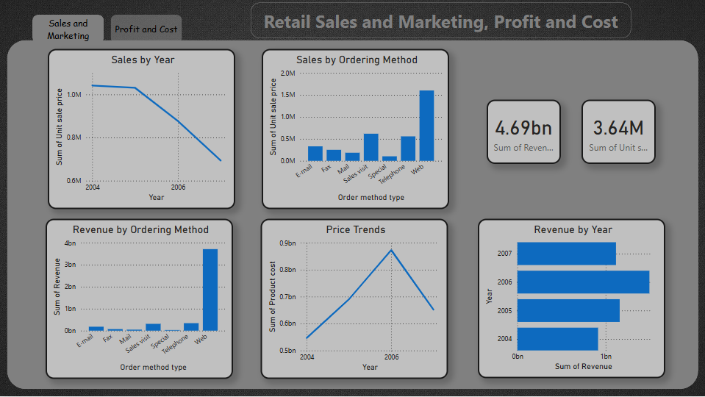
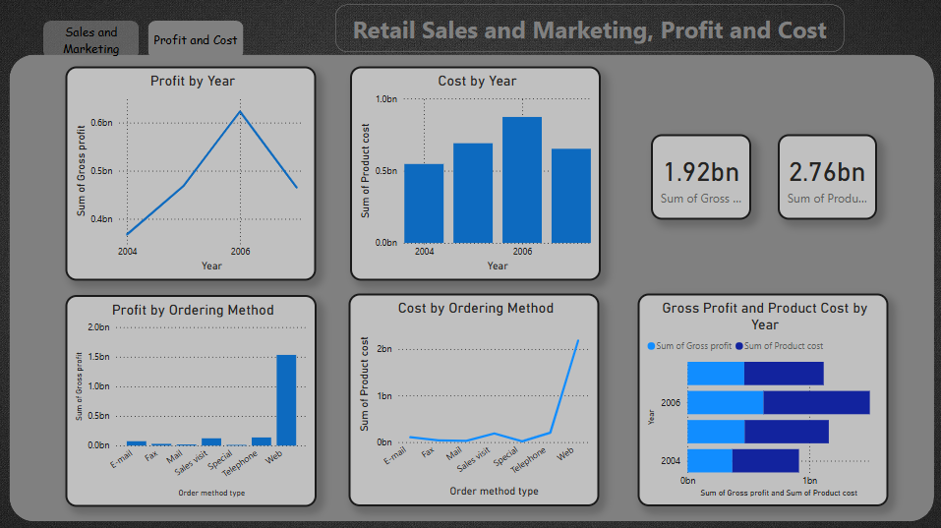
- Yearly Sales Trends Line Chart:
  - Representation: Displays total sales revenue for each year. It highlights years with the highest and lowest sales, providing a clear view of sales performance over time.
  - Insight: Identifies periods of strong sales performance and potential seasonal trends.
- Ordering Method Profitability Bar Chart:
  - Representation: Compares the total profit generated by each ordering method, showing which methods are the most and least profitable.
  - Insight: Helps determine which ordering methods to prioritize or improve upon.
- Marketing Expenses Over Years Line Chart:
  - Representation: Shows the trend of marketing expenses over the years.
  - Insight: Allows stakeholders to see if there is a correlation
- Cost vs. Profit Scatter Plot:
  - Representation: Illustrates the relationship between costs and profit, highlighting how changes in costs affect profitability.
  - Insight: Helps identify optimal cost levels for maximizing profit.

Actionable Insights
- Sales Trends:
  - Insight: Identify the years with the highest sales and analyze what factors contributed to success during these periods. This can guide future sales strategies.
- Ordering Method Profitability:
  - Insight: Focus on the most profitable ordering methods to maximize future profits. Consider improving or phasing out less profitable methods.
- Cost Management:
  - Insight: Analyze the relationship between costs and profit to find the optimal balance. Implement cost control measures where necessary to improve profitability.
These insights provide a clear path forward for stakeholders to make informed decisions based on the data analysis. The visualizations created in Power BI are crucial tools for interpreting the data and guiding strategic actions.

Conclusion
The analysis and visualizations created in Power BI provide valuable insights into Company's sales, marketing, profit, and cost data. By understanding these trends and relationships, stakeholders can make data-driven decisions to support the company's expansion and future success. The interactive dashboards created in Power BI are essential tools for visualizing complex data and making it accessible to all stakeholders.

